**EXPERIEMENT NO. 4**

Aim: To setup a network and configure IP addressing, subnetting, masking using CISCO Packet Tracer.

Requirements: Windows O.S and CISCO Packet Tracer.

Theory:

**What is a subnet?**

A subnet, or subnetwork, is a network inside a network. Subnets make networks more efficient. Through subnetting, network traffic can travel a shorter distance without passing through unnecessary routers to reach its destination.

Like the postal service, networks are more efficient when messages travel as directly as possible. When a network receives data packets from another network, it will sort and route those packets by subnet so that the packets do not take an inefficient route to their destination.

**What is an IP address?**

In order to understand subnets, we must quickly define IP addresses. Every device that connects to the Internet is assigned a unique IP (Internet Protocol) address, enabling data sent over the Internet to reach the right device out of the billions of devices connected to the Internet. While computers read IP addresses as binary code (a series of 1s and 0s), IP addresses are usually written as a series of alphanumeric characters.

**What do the different parts of an IP address mean?**

This section focuses on IPv4 addresses, which are presented in the form of four decimal numbers separated by periods, like 203.0.113.112. (IPv6 addresses are longer and use letters as well as numbers.)

Every IP address has two parts. The first part indicates which network the address belongs to. The second part specifies the device within that network. However, the length of the "first part" changes depending on the network's class.

Networks are categorized into different classes, labeled A through E. Class A networks can connect millions of devices. Class B networks and Class C networks are progressively smaller in size. (Class D and Class E networks are not commonly used.)

Let's break down how these classes affect IP address construction:

**Class A network:** Everything before the first period indicates the network, and everything after it specifies the device within that network. Using 203.0.113.112 as an example, the network is indicated by "203" and the device by "0.113.112."

**Class B network:** Everything before the second period indicates the network. Again using 203.0.113.112 as an example, "203.0" indicates the network and "113.112" indicates the device within that network.

**Class C network:** For Class C networks, everything before the third period indicates the network. Using the same example, "203.0.113" indicates the Class C network, and "112" indicates the device.

**Why is subnetting necessary?**

In a Block A network (for instance), there could be millions of connected devices, and it could take some time for the data to find the right device. This is why subnetting comes in handy: subnetting narrows down the IP address to usage within a range of devices.

Because an IP address is limited to indicating the network and the device address, IP addresses cannot be used to indicate which subnet an IP packet should go to. Routers within a network use something called a subnet mask to sort data into subnetworks.

**What is a subnet mask?**

A subnet mask is like an IP address, but for only internal usage within a network. Routers use subnet masks to route data packets to the right place. Subnet masks are not indicated within data packets traversing the Internet — those packets only indicate the destination IP address, which a router will match with a subnet.

Output:

Original network (192.168.16.0) is divided into 4-subnet:

Block A subnet network address: 192.168.16.0

Block A subnet First address: 192.168.16.1

Block A subnet network address: 192.168.16.254

Block A subnet Broadcast address: 192.168.16.255

Block B subnet network address: 192.168.17.0

Block B subnet First address: 192.168.17.1

Block B subnet network address: 192.168.17.126

Block B subnet Broadcast address: 192.168.17.127

Block C subnet network address: 192.168.17.128

Block C subnet First address: 192.168.17.129

Block C subnet network address: 192.168.17.190

Block C subnet Broadcast address: 192.168.17.191

Block D subnet network address: 192.168.17.192

Block D subnet First address: 192.168.17.193

Block D subnet network address: 192.168.17.222

Block D subnet Broadcast address: 192.168.17.223

Network:

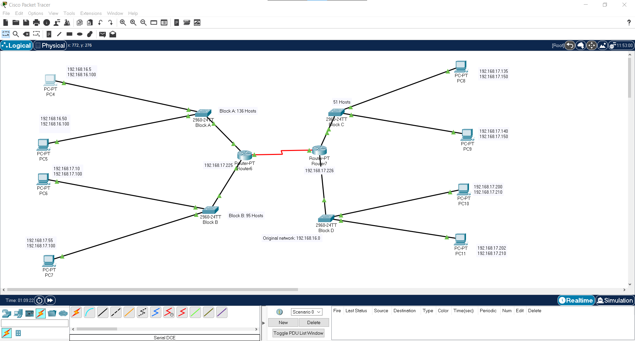

Pinging from Block A P.C to Block A and B P.C:

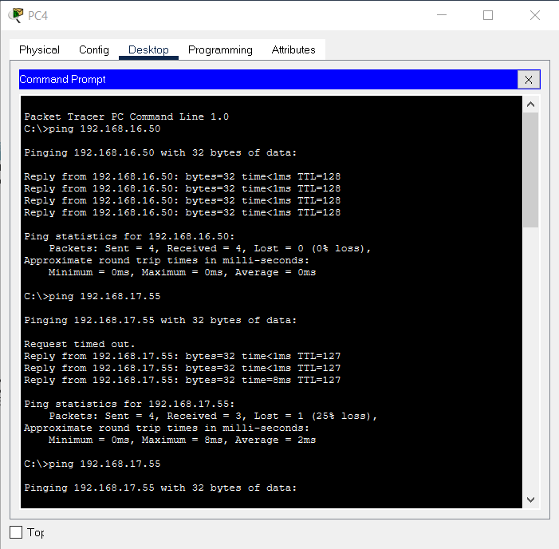

Pinging from Block A P.C to Block C P.C:

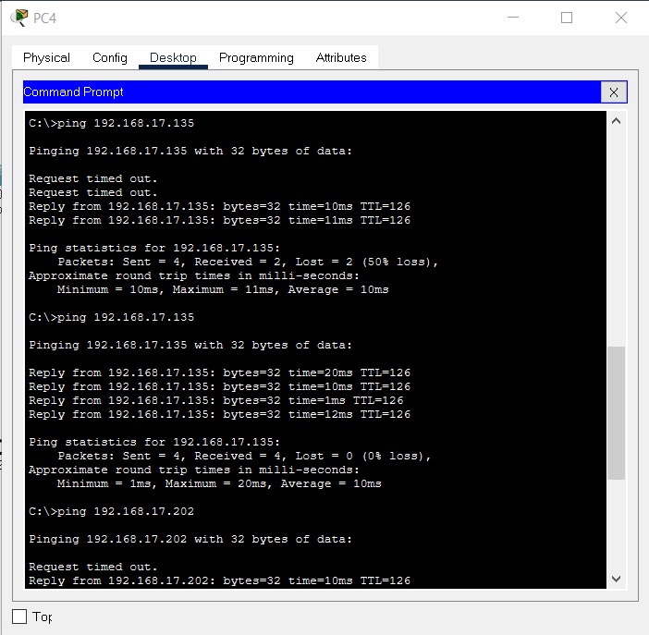

Pinging from Block A P.C to Block D P.C:

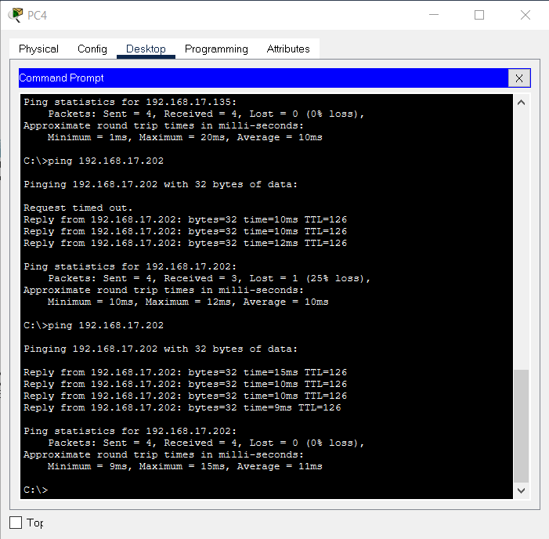

IP routing table of router after configuration:

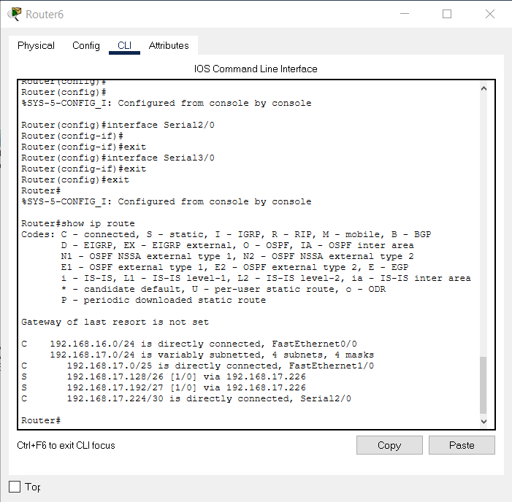

Conclusion: We have successfully setup a network and configure IP address to each P.Cs and routers and configured 4 subnets and routing table of routers to send packet packet from one subnet block to another.